**Soft delete in In Laravel**

**Definition**

Soft delete doesn’t delete the data permanently but there is one column deleted_at it mark a timestamp in that column when you soft delete

Let’s open any project to learn its implementation

**Step 1: add soft delete column in db**

php artisan make:migration alter_admin_instruction_level_models_table

  public function up()

    {

        //

        Schema::table('admin_instruction_level_models_table', function(Blueprint $table){

            $table->softDeletes();

        });

    }

    /**

     * Reverse the migrations.

     *

     * @return void

     */

    public function down()

    {

        Schema::table('admin_instruction_level_models_table', function(Blueprint $table){

            $table->dropSoftDeletes();

        });

    }

}

  Schema::create('admin_judgin_level_models', function (Blueprint $table) {

            $table->id();

            $table->string('judging_name')->nullable();

            $table->string('judging_description')->nullable();

            $table->timestamps();

        });

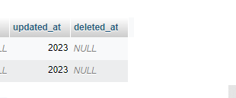

**Step 2: use softdelete in you model**

namespace App\Models;

use Illuminate\Database\Eloquent\Factories\HasFactory;

use Illuminate\Database\Eloquent\Model;

use Illuminate\Database\Eloquent\SoftDeletes;

class AdminInstructionLevelModel extends Model

{

    use HasFactory,SoftDeletes;

    protected $guarded = [];

}

Now delte anything from model using application

So we see record is not deleted from the database

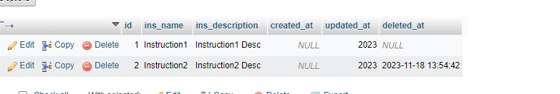

**Step 3: fetch soft delted records on page**

  public function trash_delete()

    {

        $data=  AdminInstructionLevelModel::onlyTrashed()->orderBy('id','DESC')->get();

        return view('pages.adminins.trash',compact('data'));

    }

**Step 4: recover**

  public function trash_restore($id)

    {

        $data=  AdminInstructionLevelModel::withTrashed()->findOrFail($id);

        // return view('pages.adminins.trash',compact('data'));

        if(!empty($data))

        {

            $data->restore();

        }

        return redirect()->back()->with("success", "Trash Restored successfully");

    }

                              <a href="{{route('trash.restore',$data->id)}}" style="font-size:12px;" class="btn btn-success  edit-button btn-sm" ><i class="fa-solid fa-pen-to-square" style="color: #ffffff;"></i>  Edit</a>

**Step 4: Permanantly delete**